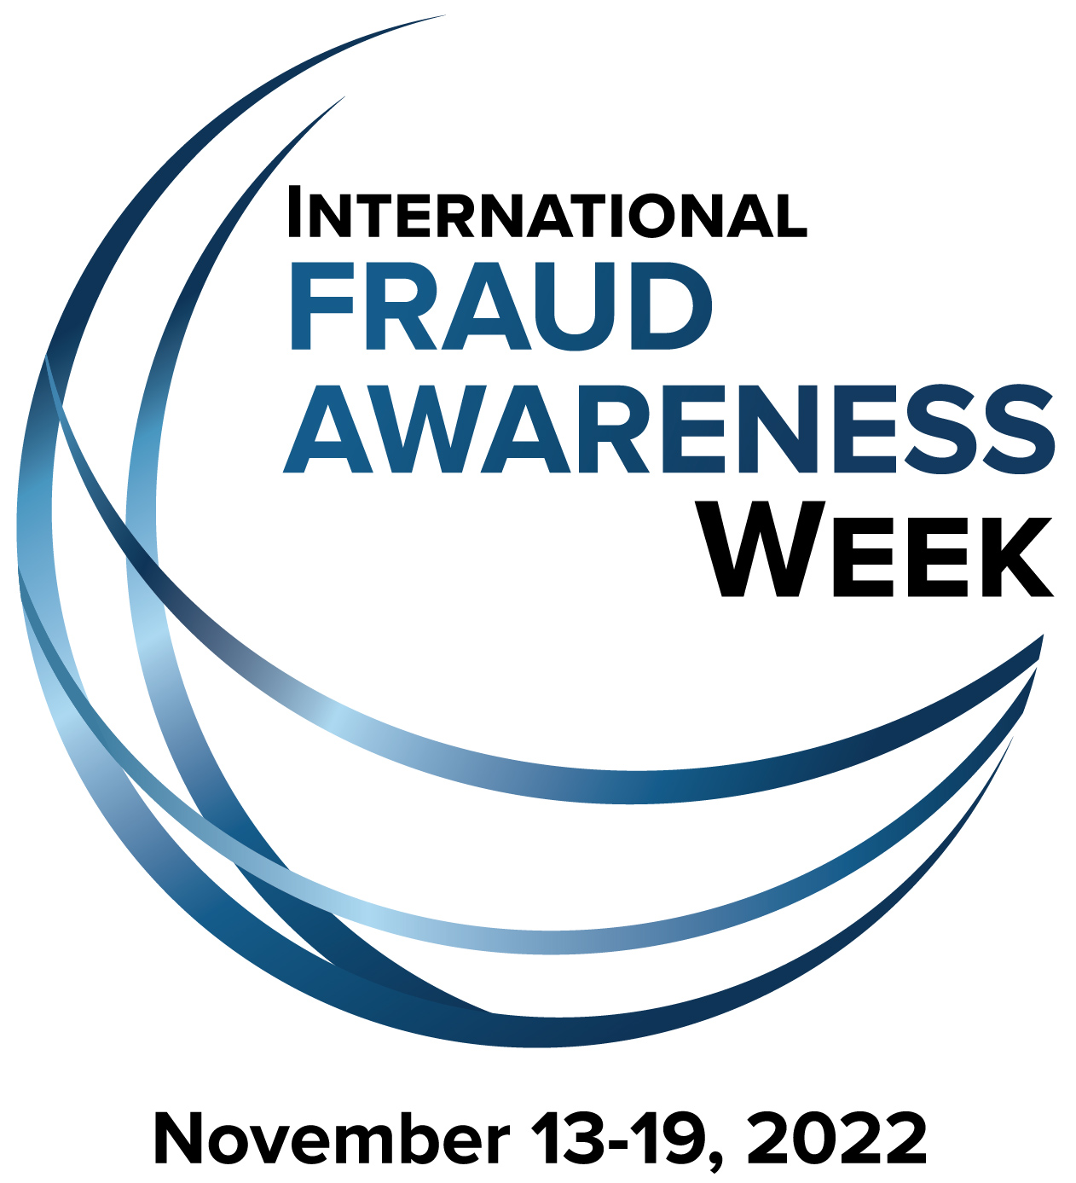

For Immediate Release
[INSERT DATE]

For More Information Contact:
[INSERT NAME & PHONE]
ACFE: Stefanie Hallgren, (512) 478-9000
E-mail: PR@ACFE.com

[INSERT ORG NAME] Joins Movement to Shine a Spotlight on Fraud
International Fraud Awareness Week kicks off Nov. 13, 2022 worldwide

[CITY, STATE]– Fraud costs organizations worldwide an estimated 5 percent of their annual revenues, according to a study conducted by the Association of Certified Fraud Examiners (ACFE). Occupational Fraud 2022: A Report to the Nations analyzed 2,110 occupational fraud cases that caused a total loss of more than $3.6 billion.

The seriousness of the global fraud problem is why [INSERT ORG. NAME] announced that it will be participating in International Fraud Awareness Week, Nov. 13-19, 2022, as an official supporter to promote anti-fraud awareness and education. The movement, known commonly as Fraud Week, champions the need to proactively fight fraud and help safeguard business and investments from the growing fraud problem.

[INSERT ORG. NAME] joins hundreds of organizations who have partnered with the ACFE, the world's largest anti-fraud organization and premier provider of anti-fraud training and education, for the yearly Fraud Week campaign.

[CUSTOMIZE THE FOLLOWING TO YOUR ORG., IF DESIRED]
During Fraud Week, official supporters will engage in various activities, including: hosting fraud awareness training for employees and/or the community, conducting employee surveys to assess levels of fraud awareness within their organization, posting articles on company websites and in newsletters and teaming up with local media to highlight the problem of fraud.

[INSERT ORGANIZATION QUOTE IF DESIRED]

ACFE president and CEO Bruce Dorris, J.D., CFE, CPA, said that the support of organizations around the world helps make Fraud Week an effective tool in raising anti-fraud awareness.

“Fraud is an issue that unfortunately affects people from all walks of life around the world and it takes many forms,” said Dorris. “Whether it’s a trusted employee stealing from a small business, or organized rings of fraudsters targeting seniors in our community, most people know someone who’s been victimized by fraud. That’s why it’s so important for organizations to join in this fight together in order to raise awareness during this week. It is a serious problem that requires a proactive approach toward preventing it and educating people is the first step.”

For more information about increasing awareness and reducing the risk of fraud during International Fraud Awareness Week, visit FraudWeek.com.

[INSERT YOUR ORGANIZATION’S “ABOUT” PARAGRAPH HERE]

About the Association of Certified Fraud Examiners
Based in Austin, Texas, the ACFE is the world's largest anti-fraud organization and premier provider of anti-fraud training and education. Together with more than 90,000 members, the ACFE is reducing business fraud worldwide and inspiring public confidence in the integrity and objectivity within the profession. For more information, visit ACFE.com.

