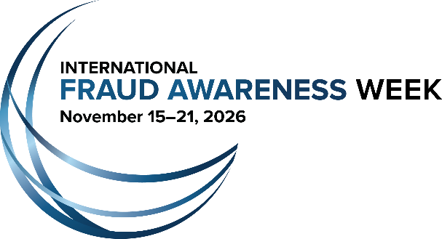

For Immediate Release
[INSERT DATE]

For More Information Contact:
[INSERT NAME & PHONE]
ACFE: Stefanie Hallgren, +1 (512) 276-8167
E-mail: PR@ACFE.com

[INSERT ORG NAME] Joins Movement to Shine a Spotlight on Fraud
International Fraud Awareness Week kicks off Nov. 15, 2026 worldwide

[CITY, STATE]– $3.4 billion lost to fraud. Those were the total losses calculated in Occupational Fraud 2026: A Report to the Nations, the latest report from the Association of Certified Fraud Examiners (ACFE) which analyzed 2,402 occupational fraud cases.

The seriousness of the global fraud problem is why [INSERT ORG. NAME] announced that it will be participating in International Fraud Awareness Week, Nov. 15–21, 2026, as an official supporter to promote anti-fraud awareness and education. The movement, known commonly as Fraud Week, champions the need to proactively fight fraud and help safeguard business and investments from the growing fraud problem.

[INSERT ORG. NAME] joins hundreds of organizations who have partnered with the ACFE, the world's largest anti-fraud organization and premier provider of anti-fraud training and education, for the yearly Fraud Week campaign.

[CUSTOMIZE THE FOLLOWING TO YOUR ORG., IF DESIRED]
During Fraud Week, official supporters will engage in various activities, including hosting fraud awareness training for employees and/or the community, conducting employee surveys to assess levels of fraud awareness within their organization, posting articles on company websites and in newsletters and teaming up with local media to highlight the problem of fraud.

[INSERT ORGANIZATION QUOTE IF DESIRED]

ACFE president and CEO John Warren, J.D., CFE, said that the support of organizations around the world helps make Fraud Week an effective tool in raising anti-fraud awareness.

“We are all working to raise awareness continuously,” said Warren. “Fraud Week provides an important annual reminder for everyone to focus on raising awareness, as well as anchor dates that bring the global community together in a coordinated effort that helps build enthusiasm for the important causes of fraud awareness and prevention.”

For more information about increasing awareness and reducing the risk of fraud during International Fraud Awareness Week, visit FraudWeek.com.

[INSERT YOUR ORGANIZATION’S “ABOUT” PARAGRAPH HERE]

About the Association of Certified Fraud Examiners
Based in Austin, Texas, the ACFE is the world's largest anti-fraud organization and premier provider of anti-fraud training and education. Together with more than 95,000 members, the ACFE is reducing business fraud worldwide and inspiring public confidence in the integrity and objectivity within the profession. For more information, visit ACFE.com.

